Developer Sample Code Exercise: Validating a Passport MZR

Please produce an example web application and web service that validates a standard international passport Machine Readable Zone (MRZ) line 2.

The example must be made up of:

1. A front end web application to collect the data to validate and display the results
2. A web service that the web applications calls to validate the data
3. A library that does the actual validation

Something like:

Web service

Web site

Validate lib

The Machine Readable Zone (MRZ) line 2 is last line of the passport and is split into sections:

#########CbbbYYMMDDCsyymmddCppppppppppppppCX

|  |  |
| --- | --- |
| Section | Description |
| ######### | Passport Number |
| C | Check digit |
| bbb | Nationality |
| YYMMDD | Date of Birth |
| C | Check digit |
| S | Sex |
| yymmdd | Passport Expiration Date |
| C | Check digit |
| pppppppppppppp | Personal Number |
| C | Check digit |
| X | Final check digit |

Requirements:

1. C# and any web technology the candidate if confident in e.g. WebForms, MVC, WCF, SOAP
2. Please follow secure coding practices e.g. input validation and output encoding
3. Please fully document the code
4. Include proper exception handling

Useful links:

<http://en.wikipedia.org/wiki/Machine-readable_passport>

<http://www.highprogrammer.com/alan/numbers/mrp.html>

<https://www.owasp.org/index.php/Top_10_2013-Top_10>

The candidate will be expected to present the working solution as part of the interview.

Wireframes: Data capture + results

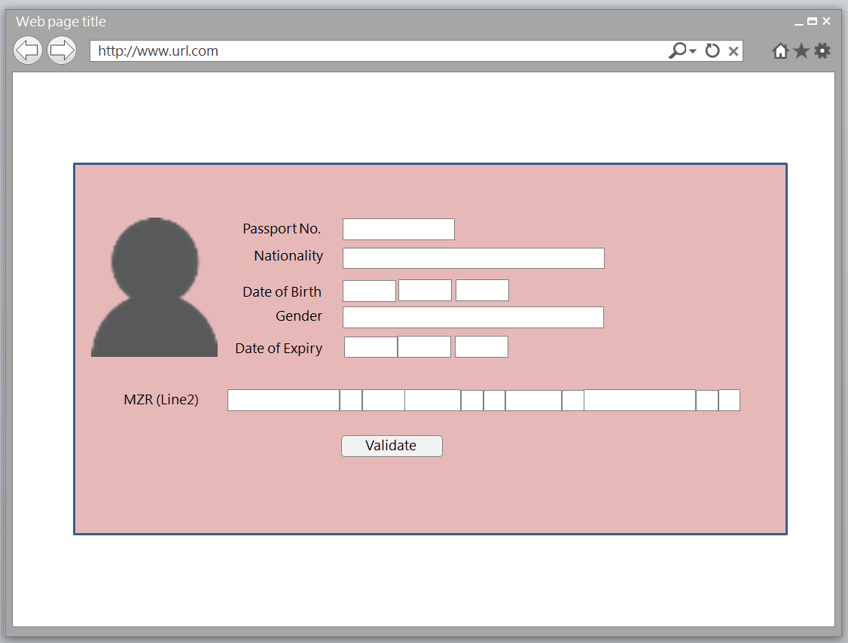

Please ensure that the data capture screen is centred on the page both vertically and horizontally. Please do not use HTML tables

